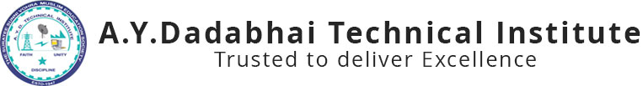

Report on
“Worshop on Web Designing”
9th & 10th AUG, 2019

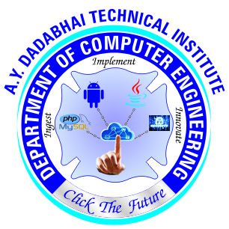

A.Y. DADABHAI TECHNICAL INSTITUTE, KOSAMBA
Kosamba-Mahuvej Road, At post : Kosamba,
Dist :Surat, Gujarat-3964120

Computer Engineering Department of A.Y.Dadabhai Technical Institute, Kosamba has arranged a workshop on website designing for 3rd and 5th semester students on 9th & 10th August 2019. Total 50 students benefitted with this workshop. As per the Curriculum of 5th Semester Diploma in Computer Engineering , students have to study php and MySQL which is useful in website designing. A.Y. Dadabhai Technical Institute is very much concerned about the Professional Development of each Student. Computer Engineering Department also takes regular steps to fulfill the Institute’s vision and as well as Department’s own vision. To pursue this vision Computer engineering Department organizes various Quiz Competition and workshops for Computer engineering Students. Mr. Sarfaraz Kazi, Mr. Kishan Modi, Ms Priyanka Patel and Mr. Arshad haezji from Soften Web Media, Surat shared their Experience on web designing with wordpress technology.
Initially all the students were provided domain name for individual website development through PayPal payment gateway. After then they had given all the essential information regarding website creation that includes e-commerce website, Informative website etc. After completion of workshop, students have enough knowledge regarding entire process of website making and hosting. So they are capable to build their own website and host it.
This Workshop was very helpful to the Students. As they were able to know the things to which they were unknown till date. Students had also asked some queries at the end of workshop and exaggerate their gratitude for the workshop planned by the Computer Department of the Institute
Glimpse of Expert Lecture

