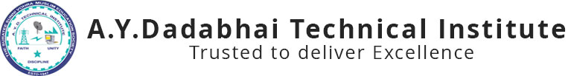

Report on
“Seminar on Web Designing”
10th DEC, 2019

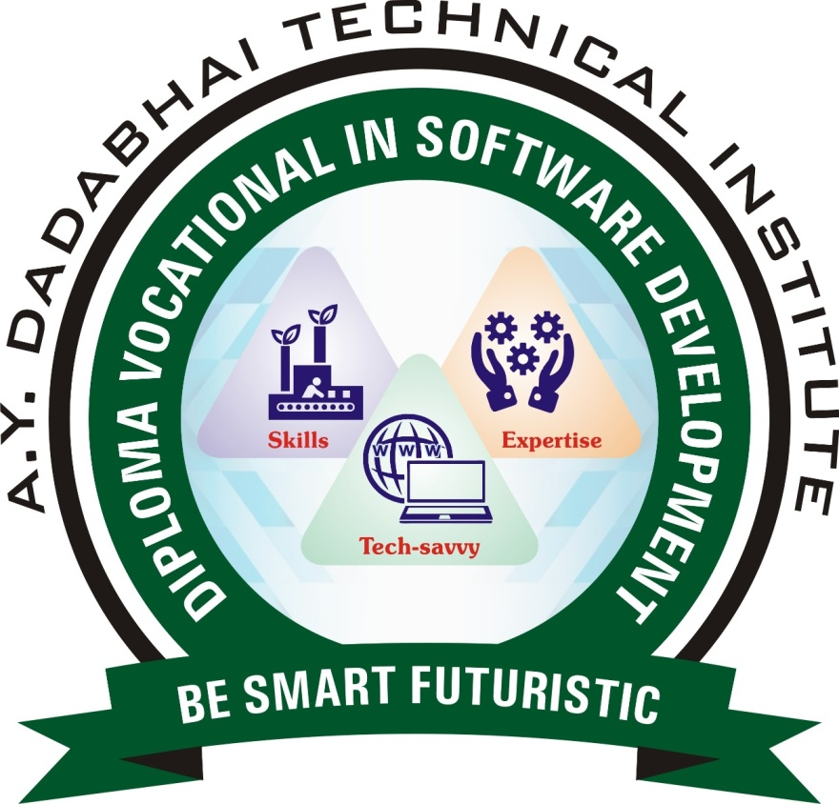

A.Y. DADABHAI TECHNICAL INSTITUTE, KOSAMBA
Kosamba-Mahuvej Road, At post : Kosamba,
Dist :Surat, Gujarat-3964120

A.Y.Dadabhai Technical Institute, Kosamba has arranged a seminar on website designing for DVOC students on 10th December 2019. Total 43 students benefitted with this seminar. As per the curriculum of 1st Semester DVOC in Software Development, students have to study web designing fundamentals which is useful in website designing. A.Y. Dadabhai Technical Institute is very much concerned about the Professional Development of each Student. Our department also takes regular steps to fulfill the Institute’s vision as well as Department’s own vision. Mr. Ayaz Memon and Mr. Krunal from The Z Web Solution, Ankleshwar shared their Experience on web designing fundamentals.
This Workshop was very helpful to the Students. As they were able to know the things to which they were unknown till date. Students had also asked some queries at the end of workshop and exaggerate their gratitude for the workshop planned by the Computer Department of the Institute
Glimpse of Expert Lecture
