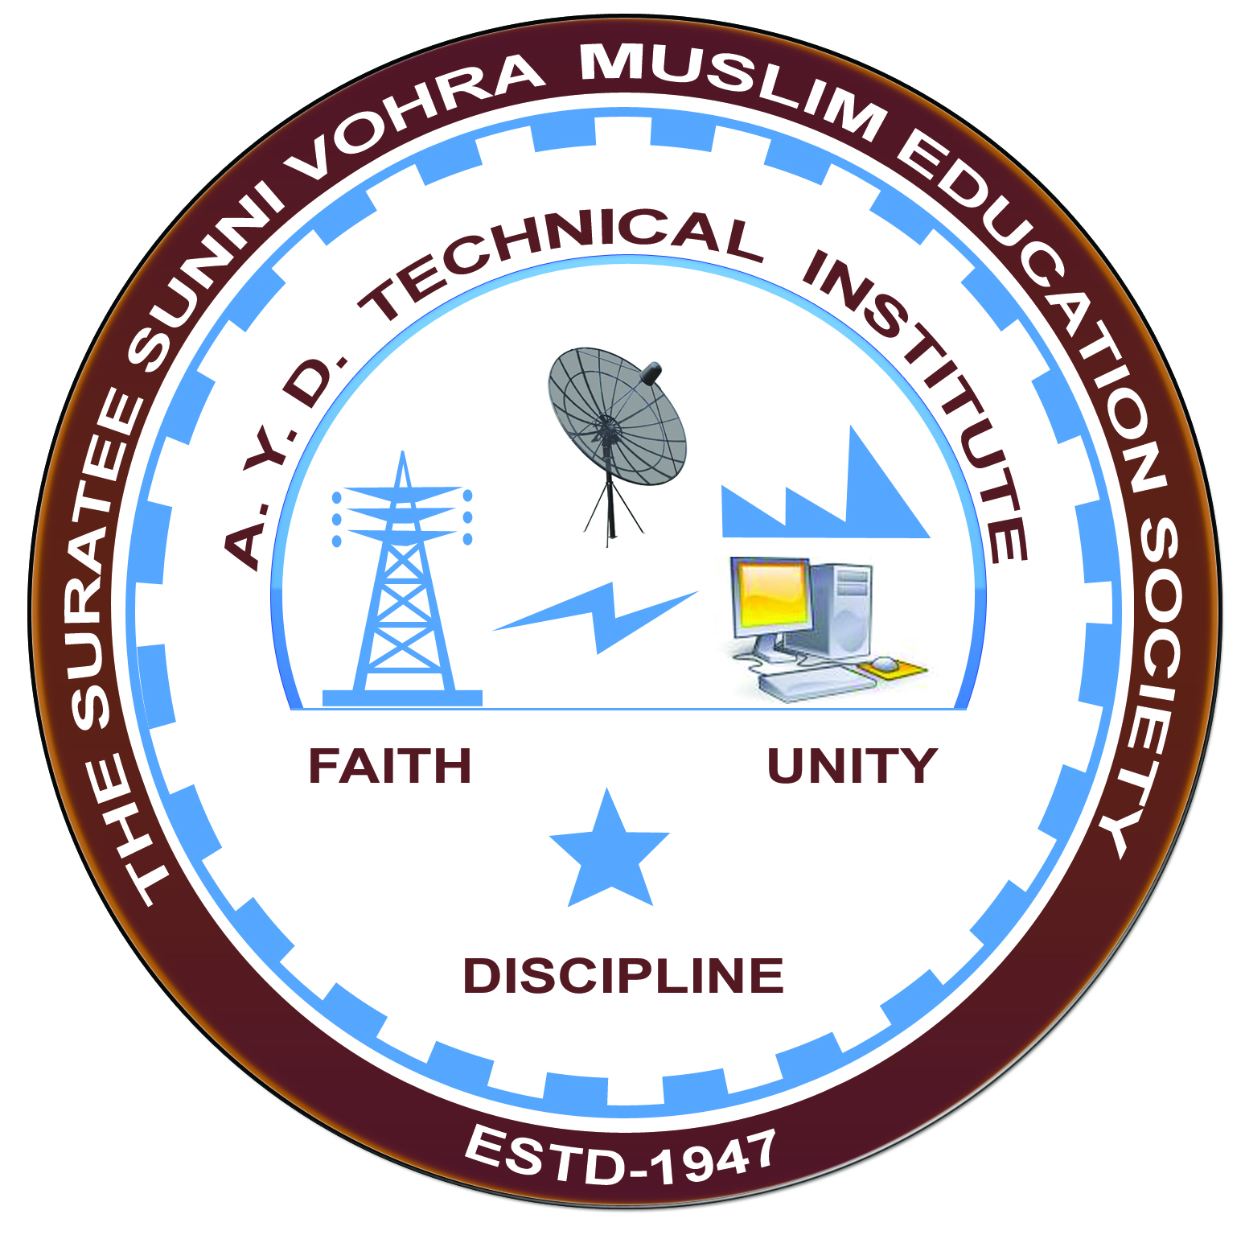

**Report on Expert Lecture**

**ELECTRICAL POWER GENERATION & TRANSMISSION.**

**Arranged by**

**Electrical Engineering Department,**

**A.Y.DADABHAI TECHNICAL INSTITUTE, KOSAMBA**

**EXPERT LECTURE**

**Date:-** 30/08/2019

**Department:-** Electrical Engineering

**Sem:-** 3rd Semester

**Faculty:-** (1) Mr. M. A. Sheikh

(2) Mr. M. R. Vansiya

**No Of Students :-** 55

|  |  |  |
| --- | --- | --- |
| **Name Of Expert** | **Designation** | **Organization Of Expert** |
| Mr. D. N.. Shah | Executive Engineer | SLDC Vadodra  (GETCO) |

**Topic Of Expert Lecture:-** Electrical Power Generation & Transmission.

**Brief About Expert Lecture:-**

Our electrical engineering department of A. Y. Dadabhai Technical Institute, Kosamba Had organized expert lecture of Electrical Power Generation & transmission on the date of 30 August 2019

Mr. D. N. Shah has given brief overview about different types of generating system like thermal, Gas based, Nuclear & Solar based power generation. They cover the following topics

* Power Generation Scenario Of INDIA & Gujarat
* Brief Description about Modern Power System.
* HVAC & HVDC Transmission
* Function Of Load Dispatch Centre
* Different Types of Protection Used In Transmission System.

Finally Students discuss their query & technical problems with experts.

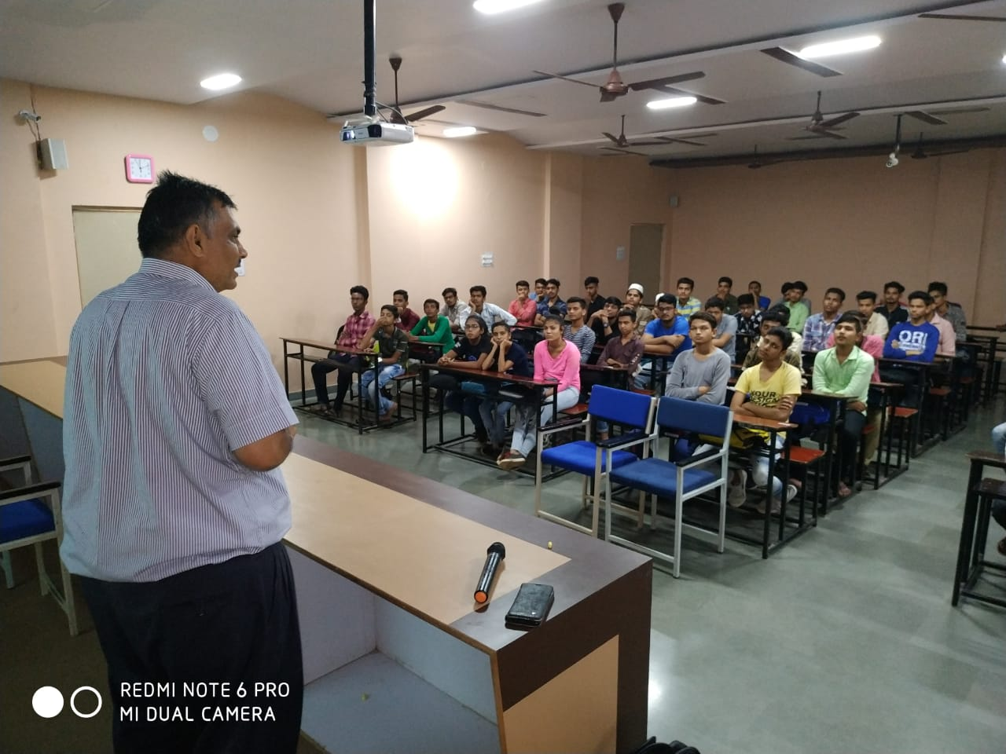

**MR.D.N.SHAH DELIVERING LECTURE**

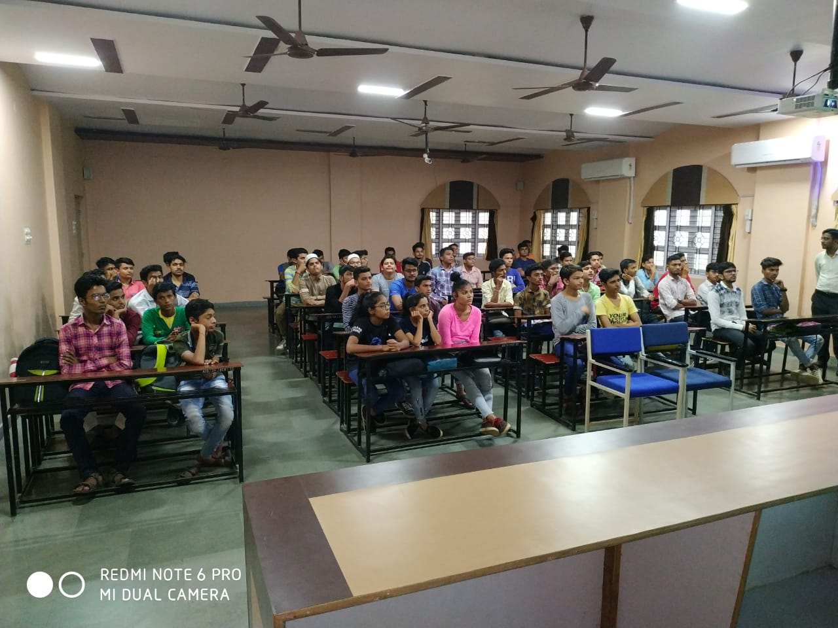

**STUDENTS PARTICIPATED**