A. Y. Dadabhai Technical Institute, Kosamba

# Report

**ON**

# EXPERT LECTURE

# WEB DEVELPOMENT USING WORDPRESS

# BY

**Mr. Himanshu Prajapati,**

Founder - Techomax Solution

5th October 2024

**Organized by**

**Computer Department**

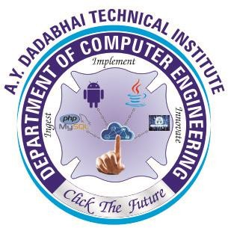

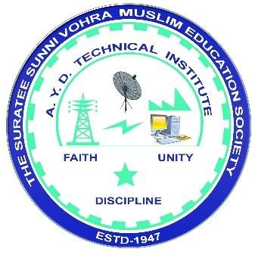

A. Y. Dadabhai Technical Institute, Kosamba

**Mahuvej Road, At & Po. Kosamba (R.S),**

**Dist: Surat**

**Details of Expert Lecture on “WEB DEVELPOMENT USING WORDPRESS "**

**Date:** October 5, 2024

**Time:** 12 PM onwards  
**Venue:** A.Y. Dadabhai Technical Institute, Kosamba  
**Organized by:** Computer Department, A.Y. Dadabhai Technical Institute  
**Speaker:** Mr. Himanshu Prajapati,

Founder - Techomax Solution

**Introduction**

On 5th October 2024, the Computer Engineering Department of A.Y. Dadabhai Technical Institute, Kosamba, organized an expert lecture on "WEB DEVELPOMENT USING WORDPRESS" for the 3rd-semester students. The event aimed to provide students with practical insights into WordPress as a popular tool for building websites and to enhance their understanding of web development in a professional context.

**Objectives**

The primary objective of this session was to provide students with an understanding of web development using WordPress, a widely-used content management system. The lecture aimed to bridge the gap between theoretical knowledge and practical implementation by:

* Introducing the fundamentals of WordPress and its applications.
* Demonstrating the process of building and managing websites using WordPress.
* Highlighting industry best practices and career opportunities in web development

**Program Overview**

The lecture was designed to cover key aspects of Python programming, including:

1. **Introduction to WordPress:**
   * Overview of WordPress as a CMS.
   * Its relevance and popularity in the web development industry.
2. **Getting Started with WordPress:**
   * Installing and setting up WordPress.
   * Understanding the WordPress dashboard.
3. **Theme and Plugin Management:**
   * Selecting and customizing themes to match user requirements.
   * Installing and utilizing plugins to extend functionality.
4. **Building a Website:**
   * Step-by-step demonstration of creating a basic website.
   * Adding pages, posts, and media content.
5. **Best Practices in WordPress Development:**
   * Ensuring website security and performance.
   * SEO optimization techniques for WordPress sites.
6. **Industry Applications and Career Opportunities:**
   * Real-world examples of WordPress applications.
   * Tips for pursuing a career in web development.

**DATE: 05/10/2024**

**Expert Lecture on "WEB DEVELPOMENT USING WORDPRESS”**

A.Y. Dadabhai Technical Institute, Kosamba aims to cater the society with skilled manpower and Efficient team members. Institute believes in total improvement of each students. Since 2009 Computer Department of A.Y. Dadabhai Technical Institute has served many scholar students to the society. Today’s Era is Computer and Internet Era.

Hence we, at Computer Department planned the Expert Lecture on **WEB DEVELPOMENT USING WORDPRESS** for 3rd  **semester** students on 5th October 2024. We invited Mr. Himanshu Prajapati, Founder - Techomax Solution to deliver the Useful Information and Make the Students aware about the Different technologies as well what are the most popular technologies in the world currently.

The session commenced with a warm welcome, who introduced the speaker and outlined the purpose of the lecture. Mr. Himanshu Prajapati then took over and began with a brief overview of the evolution of web development and the role of content management systems (CMS) like WordPress in simplifying the process.

After the detailed presentation, students had the opportunity to ask questions and clarify their doubts. The speaker addressed various queries related to web applications in industry, best practices for coding in web, and how students can enhance their programming skills through projects and certifications.

This Session has opened up many horizons among Student’s mind, specifically to choose their Career. . Students were encouraged to practice of web coding regularly and explore its vast potential in different areas of technology.

Overall the purpose for organizing this Expert Lecture is fulfilled completely. Student had cherished this experience and also showed their interest to attend further workshops in their curriculum. The expert lecture was highly beneficial for the students. The expert lecture proved to be a valuable learning experience for the students, equipping them with fundamental knowledge of WordPress and its applications in web development. It motivated them to explore further opportunities in the field and provided them with the confidence to implement their skills in real-world projects.

Glimpse of the Seminar

