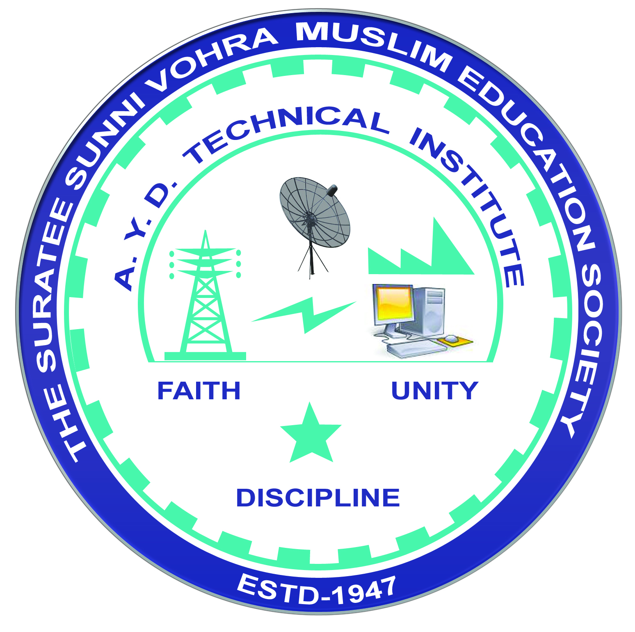 | A.Y. DADABHAI TECHNICAL INSTITUTE, KOSAMBA | 

DEPARTMENT OF MECHANICAL ENGINEERING

Industrial Visit Report

Name of Industry: Dormer Tools India Pvt. Ltd.
Address: Plot no-903, 04 G.I.D.C. Industrial Estates, Ankleshwar-393002
Date of Visit: 17-01-2025
Semester: 4th
No. of Students Visited: 42
No. of Faculty Visited: 02
Subject (Course) Related to Industry: M.E.-II (4341904)
Contact person of Industry: Mr. Sanjay Makwana
Contact No: 9099749419
Name of departments visited in Industry: Material Testing, Production, Quality Control, Heat Treatment, Colour Coating, Packaging and Store.
Photographs:
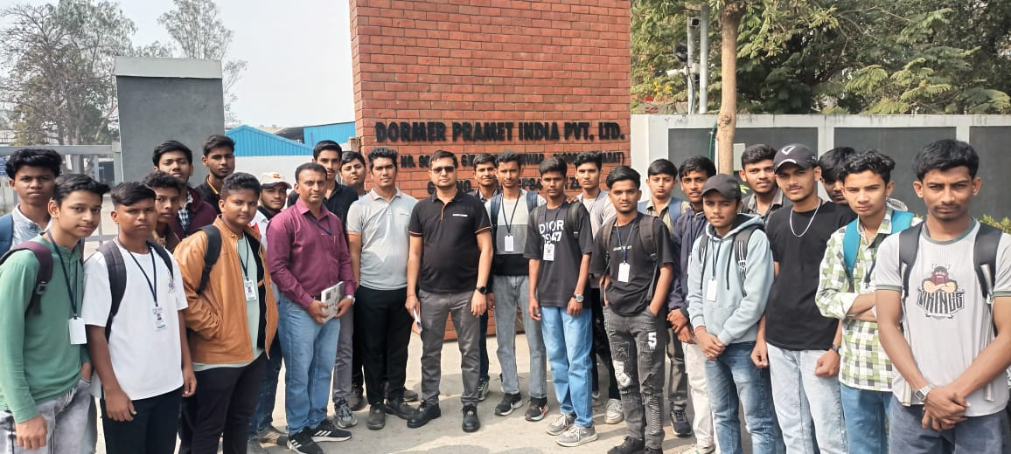 | 