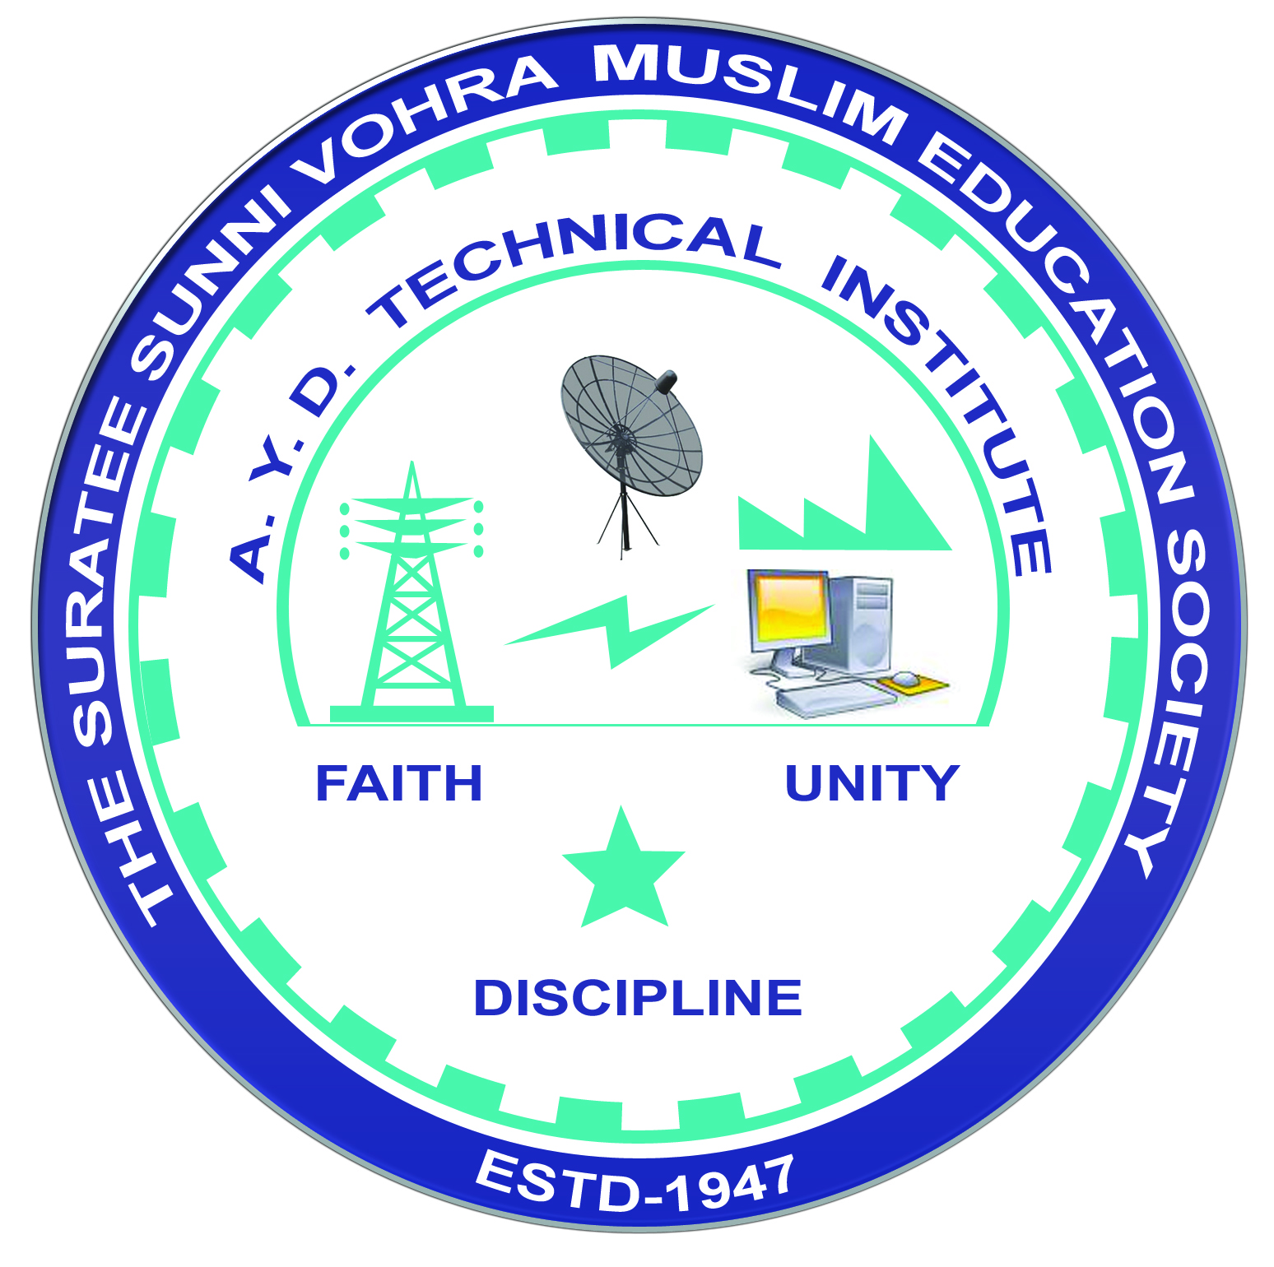 | A.Y. DADABHAI TECHNICAL INSTITUTE, KOSAMBA | 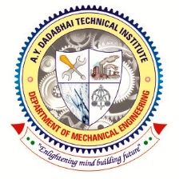

DEPARTMENT OF MECHANICAL ENGINEERING

Report

Name of Expert: Mr. Dipak Patel
Designation: DGM-ENGINEERING
Address: PGP GLASS PVT. LTD. KOSAMBA
Date of Lecture Conduct: 08-02-2025
Semester: 6th Semester
No. of Students: 27
Subject (Course) Related to Expert Lecture: - Beyond Syllabus
Topic Covered: “Sustainability and ESG Matrix”.
Time:-10.00 am to 12.00 pm.
Photographs:

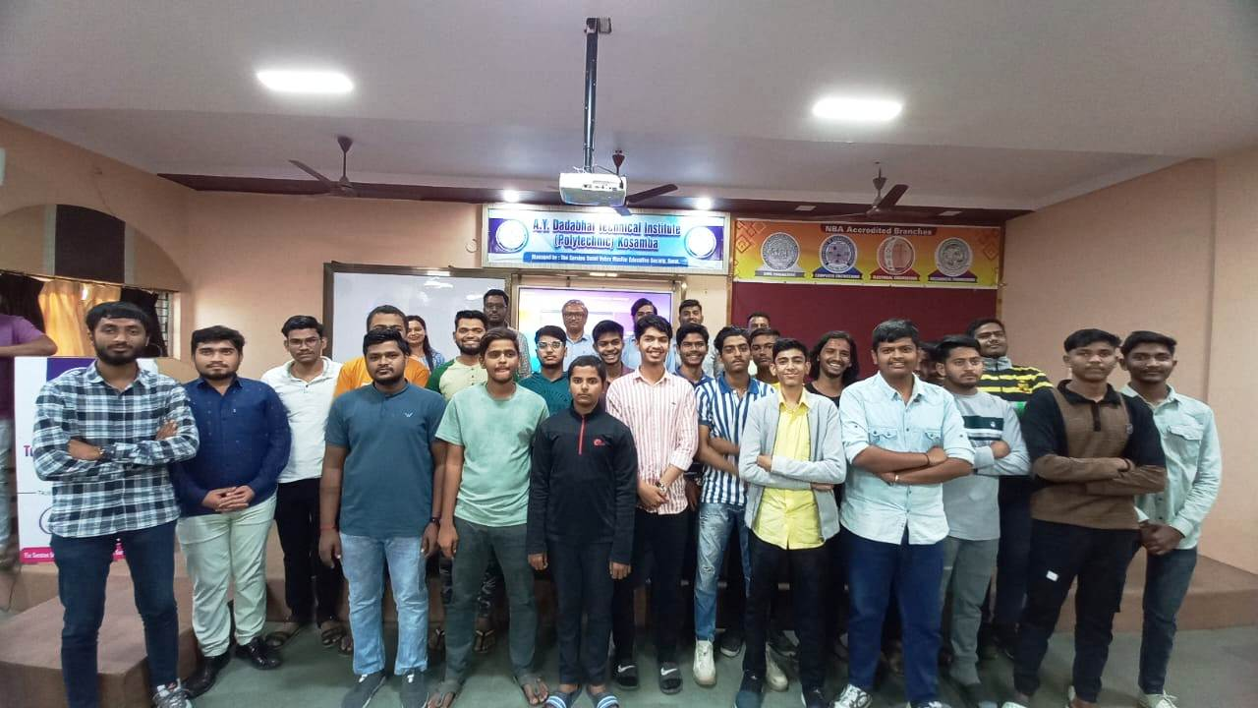 | 